

Serverless IoT Data Processing

Serverless computing is changing the way we process data. When applied to IoT data, it unlocks new possibilities and challenges. In this document, we’ll explain what serverless computing is, how it can be used for IoT data processing, and its benefits and challenges.

By:SANTOSH T

# What is Serverle**ss** Computing?

## Definition

Serverless computing is a cloud computing model where the cloud provider manages the infrastructure and automatically allocates computing resources as needed.

## Advantages

### 1 Scalability

You only pay for the resources you use, which is great for handling unpredictable traffic or workloads.

### Reduced Costs

Since you're not managing servers, you can save on infrastructure and operational costs.

### Focus on Code

You don't have to worry about provisioning, maintaining, or updating servers. You can focus purely on writing code.

# What is IoT Data Proce**ss**ing?

The Internet of Things (IoT) is the interconnection of physical devices, vehicles, buildings, and other items embedded with electronics, software, sensors, and network connectivity that enables these objects to collect and exchange data.

IoT data processing refers to the collection, storage, and analysis of data generated by IoT devices. This data can be used to drive business insights, detect patterns, or trigger actions.

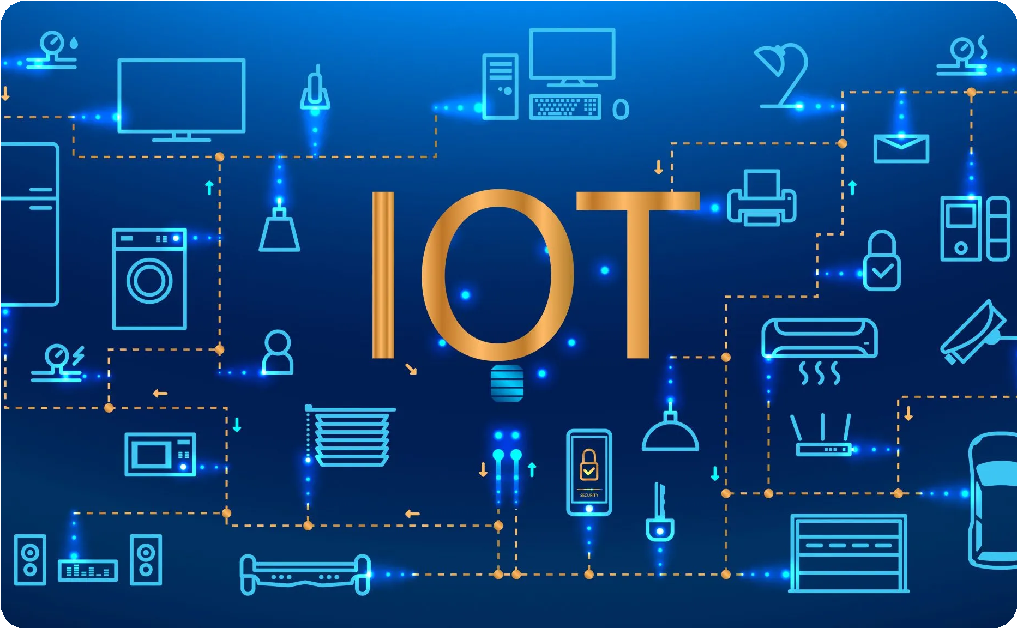

### Efficiency

Serverless can handle bursty workloads, which is important when you have a large fleet of IoT devices generating data intermittently.

### Scalability

Serverless can easily scale as your fleet of devices grows over time.

### Security

Since the cloud provider manages the infrastructure, they're responsible for securing the servers and handling updates and patches.

# Benefits of Serverle**ss** IoT Data Proce**ss**ing

Benefit Explanation

Cost

With serverless, you only pay for what you use, which can be more cost-effective than provisioning your own servers or using traditional cloud computing solutions.

Scalability

When dealing with IoT data, workloads can be unpredictable. Serverless can easily scale up or down based on demand, without the need for manual intervention.

Developer Experience

Serverless abstracts away the need for infrastructure management and allows developers to focus purely on writing business logic. This can lead to faster development cycles and quicker time-to-market.

# Challenges of Serverle**ss**IoT Data Proce**ss**ing

Vendor Lock-In: Since serverless is a relatively new technology, there is a risk of vendor lock-in. Once you start using a cloud provider's serverless technology, it can be difficult to switch providers if you decide to do so.

Cold Starts: Cold starts happen when a function hasn't been used for a while and the cloud provider has to allocate new resources for it. This can cause a delay in processing time.

Debugging: Debugging serverless services can be challenging. Traditional debugging techniques often don't work, and new tooling is required.

# Conclusion

Serverless computing is a powerful technology that can be used for IoT data processing. By abstracting away infrastructure management, serverless allows developers to focus purely on writing business logic and can lead to faster development cycles. However, there are also challenges, including vendor lock-in, cold starts, and debugging. As with any technology, it's important to carefully weigh the pros and cons before adopting a serverless approach.